Task 1: [3 marks]

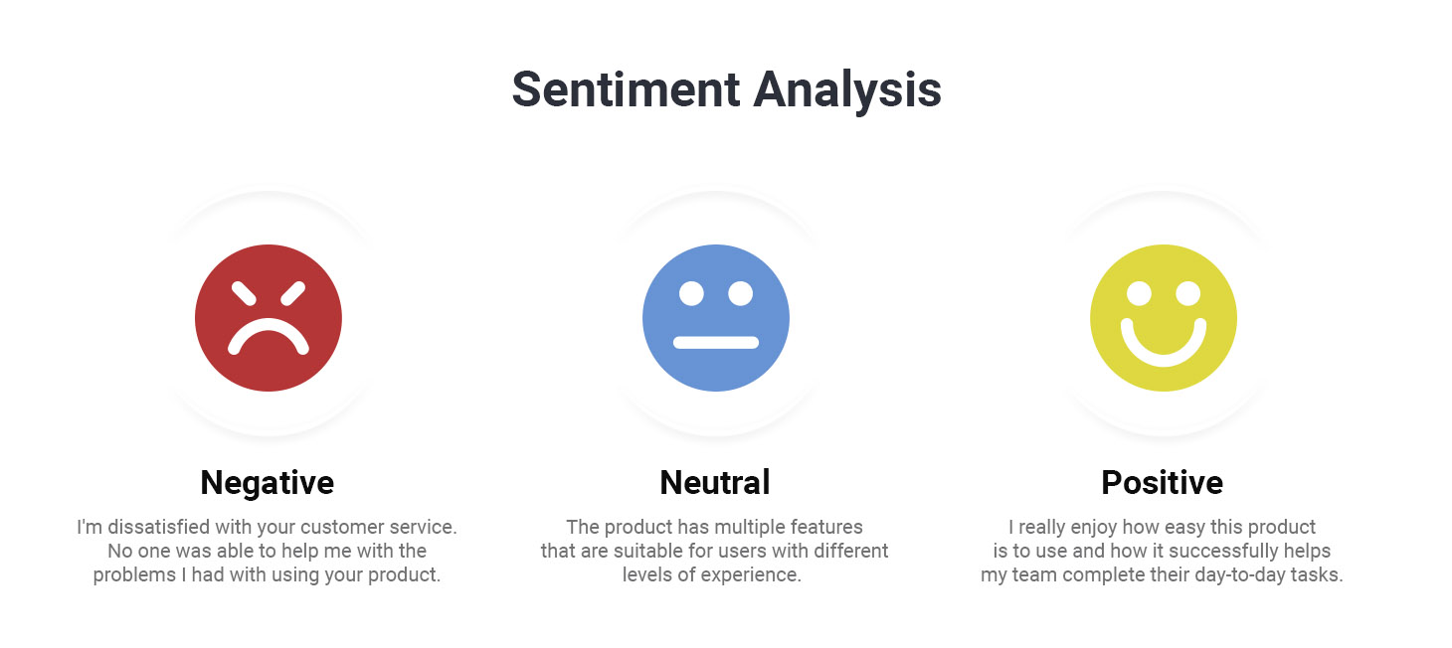

Sentiment analysis is the interpretation and classification of emotions within text. Write a simple rule-based sentiment analyser, which takes a string as input and returns its sentiment (positive, negative, neutral).
Here’s a basic example of how a rule-based system works:
- Define two lists of polarised words (e.g. negative words such as bad, worst, ugly, and positive words such as good, best, beautiful).
  - HINT: You can use Bing Liu's lists of positive and negative sentiment words (RAR archive). You should directly wget them to your notebook from: http://ptrckprry.com/course/ssd/data/positive-words.txt and http://ptrckprry.com/course/ssd/data/negative-words.txt
- Count the number of positive and negative words that appear in a given text.
- If the number of positive word appearances is greater than the number of negative word appearances, the system returns a positive sentiment and vice versa. If the numbers are even, the system will return a neutral sentiment.

import pandas as pd

!wget http://ptrckprry.com/course/ssd/data/positive-words.txt #Opinion Lexicon: Positive Words; source: http://www.cs.uic.edu/~liub/FBS/sentiment-analysis.html
!wget http://ptrckprry.com/course/ssd/data/negative-words.txt #Opinion Lexicon: Negative Words; soruce: http://www.cs.uic.edu/~liub/FBS/sentiment-analysis.html

filePath1 = "/content/positive-words.txt"
filePath2 = "/content/negative-words.txt"

posWords_df = pd.read_csv(filePath1,sep='\t',header=None, names=['words'],encoding='latin-1',skiprows=[i for i in range(0,34)]) #Latin-1 (ISO-8859-1) character set. Use chardet lib if needed
negWords_df = pd.read_csv(filePath2,sep='\t',header=None, names=['words'],encoding='latin-1',skiprows=[i for i in range(0,34)])

print(f'Number of posWords: {len(posWords_df)} Number of negWords: {negWords_df.size}')
display(posWords_df.head(10))
display(negWords_df.head(10))

Expected Output: (you need to devise a method for generating confidence scores; you can achieve this in a single line of code)
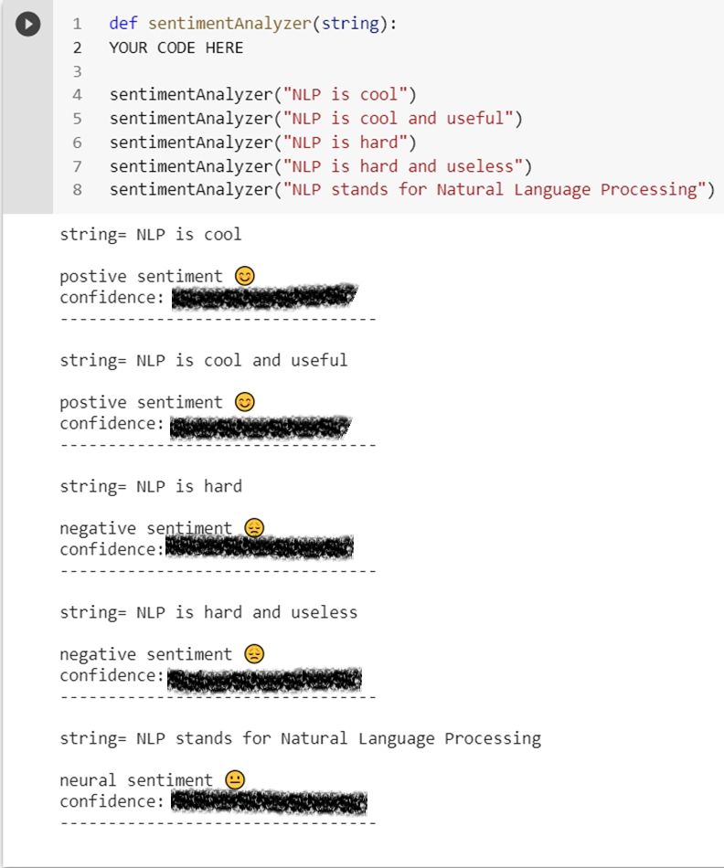

Task 2: [7 marks]
Write a NaiveBayes function which takes the sample training and testing documents shown in the table below as input, and uses the Naive Bayes algorithm to classify the test documents.
- Hint 1: Python Dictionaries are suitable data structures for storing BoWs (Bag of Words)

 | Doc | Words | Class
Training | 1 | London is the Capital of GB | GB
Training | 2 | Oxford is a city in GB | GB
Training | 3 | Dublin is the capital of Ireland | IE
Training | 4 | Limerick is a city in Ireland | IE
Test | 5 | University of Limerick | ?
Test | 6 | University College Dublin | ?
Test | 7 | Imperial College London | ?
Test | 8 | University of Oxford | ?
Test | 9 | Ireland & GB | ?

Expected Output:

def naiveBayesClassifier(trainingSet,testSet):

YOUR CODE HERE

trainingSet = [('London is the Capital of GB','GB'),('Oxford is a city in GB','GB'),('Dublin is the capital of Ireland','IE'),('Limerick is a city in Ireland','IE')]

testSet = [('University of Limerick','?'),('University College Dublin','?'),('Imperial College London','?'),('University of Oxford','?'),('Ireland & GB','?')]

naiveBayesClassifier(trainingSet,testSet)

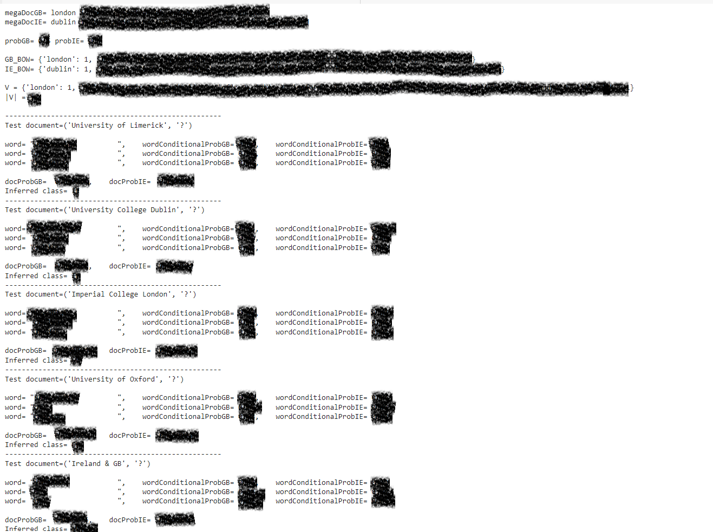

</END OF ETIVITY>

Teaching Team:
- Level of difficulty (easy/fair/hard)
- Task 1: Print the total number of positive and negative words
- Stop word removal, stemming, and unknown words
- 3 classes
- Task 3: [5 marks] sentiment analysis
- There is the chardet library that uses that study to try to detect encoding. chardet is a port of the auto-detection code in Mozilla. https://stackoverflow.com/questions/436220/how-to-determine-the-encoding-of-text

Hint3: Is there any Pythonic way to combine two dicts (adding values for keys that appear in both)?

Hint 4: How to use the math.isclose() function in Python?

